CSE-326 (Internet Programming Laboratory)

CA-1



Project Title:

Roadkill site: Take pics of roadkill and upload them to your site. People will love it or hate it

Submitted By: Submitted to:

Name: Saurabh kumar Faculty Name:pooja Rana Registration No.: 12116525

Roll No.: RKOCO4A48 Group:01

Project Link:

Complete project along with all the HTML, CSS & JavaScript files & Images is uploaded on this following link:

<https://github.com/shubu02/cse326.git>

Introduction:

I have made this project using HTML, CSS & JavaScript. “Index.html” file is the core file which has all the other files linked to it. Core code of the website is written in HTML & CSS is used to provide style to website & JavaScript is used to add logic to the website.

Specifically, JavaScript is used in “Add to Cart” buttons in Subscription Page.

&

All the pictures used on the website are present in the “Img” folder

Website Screenshots with Explanation:

Homepage: • When we open the “Index.html” file the first thing that we see is our Homepage.

Image 1 

• I have divided Homepage into 4 Major Sections:

1st is home section

2nd is image section

3rd is about section

4th is contact section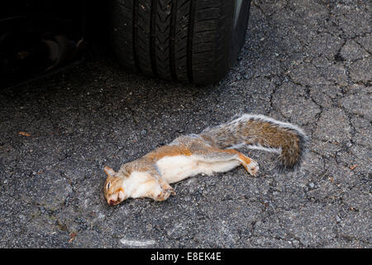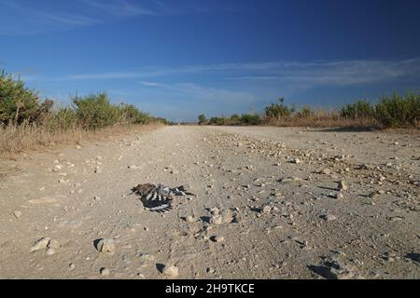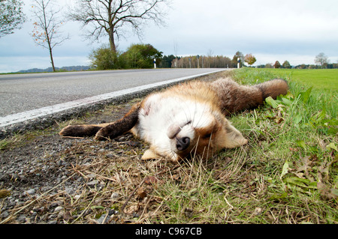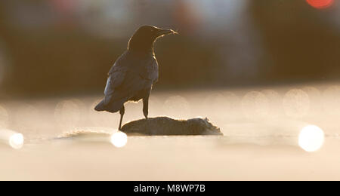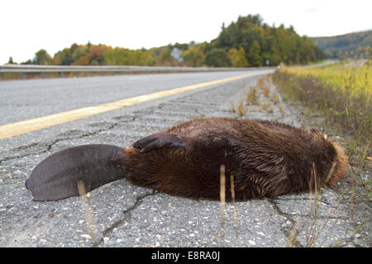

Blog Pages:

• I have Created 3 Full-Blog pages: Blog- 1, Blog- 2 & Blog- 3 and connected them to the “Read Blog” button using Anchor tag in Homepage “Blogs Section” in “Blog Preview”. To navigate through the page these Blog pages also have Navigation Bar, but I had to customize Homepage Navigation Bar for these pages as there is no other content other than blog content on these pages. So the Anchor tags assigned to Homepage Navigation Bar for auto scrolling to the designated sections will not work here, that’s why I made a Dropdown menu in “Blogs” section in “Blog Page’s Navigation Bar” and attached blog pages using Anchor tag to the “Blogs” section in Navigation Bar so that you can switch between these blogs easily and I also made Individual “Subscription Page” & “Contact Us

**THANK YOU!**